Daniel Koirala
CSIII
Lab 3 Report

Output:

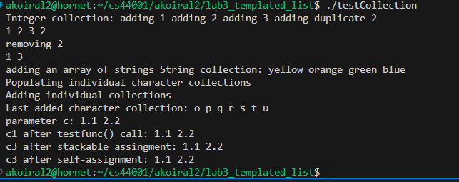

AI Usage:

Used github co-pilot for help in writing the code. It mostly filled in the stuff I had to repeatedly write.

